BC Menu
cm_contents.html — Basic Concepts
Define ICT
Hardware and Software
Data vs Information

NB You must take the PreQuiz to be able to access the modules!:
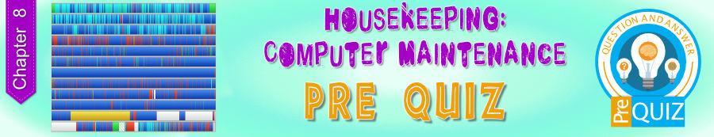

Modules for this Chapter:

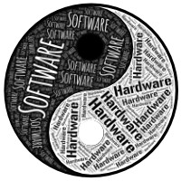
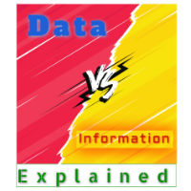

Take the Quizzes to help you learn!
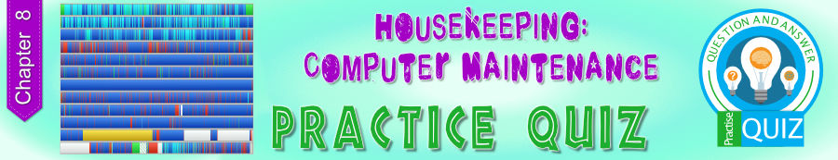
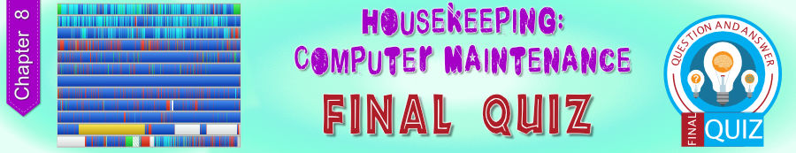

Other Resources for this Chapter
Lessons
This lesson is a basic summary and overview of the contents of this chapter.
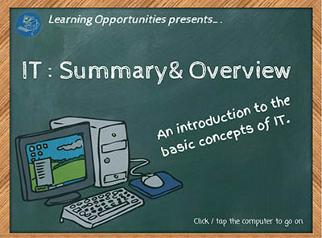
This lesson is a detailed look at the different types of computers and what they are used for.
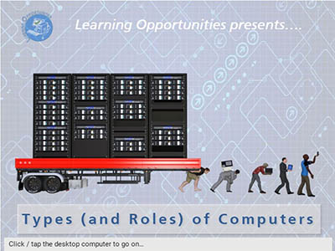
This lesson is a detailed look at the IPO model.
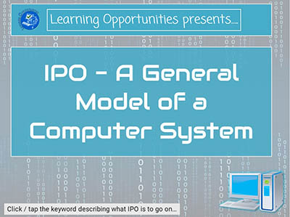
This lesson is a detailed look at the difference between Data and Information.
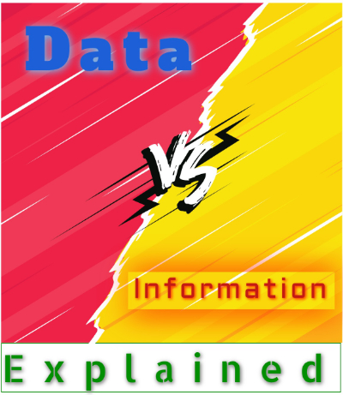
Quizzes

Basic Concepts Quizzes

Practice Quiz
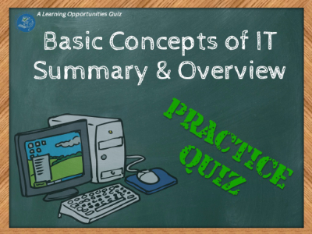
This quiz lets you do random questions with no time limit. It will be slightly different each time you take it.

Practice Quiz - ALL QUESTIONS
This quiz lets you do all the questions in the Basic Concepts quiz. You do not have to complete the quiz all at once, but can come back and continue where you left off.

FINAL QUIZ!
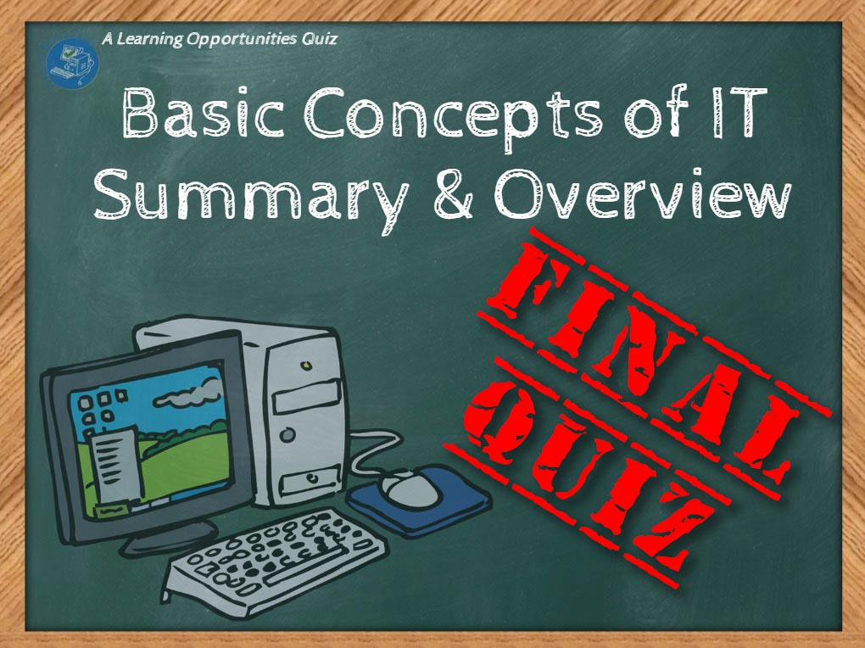
This quiz lets you do random questions - with a time limit.
NB: This quiz can only be taken once and your marks are final.

Types of Computers Quizzes

Practice Quiz
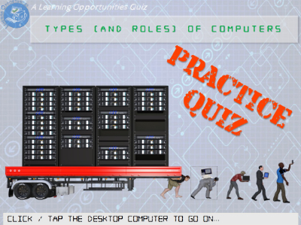
This quiz lets you do 20 random questions with no time limit. It will be slightly different each time you take it.

Practice Quiz - ALL QUESTIONS
This quiz lets you do all the questions in the Types of Computers quiz.
You do not have to complete the quiz all at once, but can come back and continue where you left off.

FINAL QUIZ!
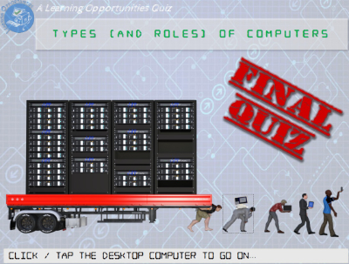
This quiz lets you do 20 random questions - with a time limit.
NB: This quiz can only be taken once and your marks are final.

IPO Model Quizzes

Practice Quiz
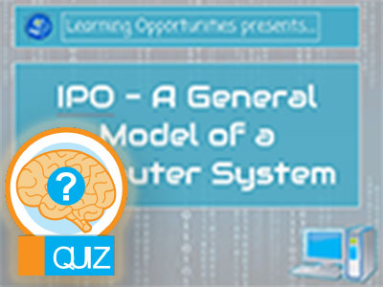
This quiz lets you do 10 random questions with no time limit. It will be slightly different each time you take it.

Practice Quiz - ALL QUESTIONS
This quiz lets you do all the questions in the IPO Model quiz. You do not have to complete the quiz all at once, but can come back and continue where you left off.

FINAL QUIZ!
This quiz lets you do 10 random questions - with a time limit.
NB: This quiz can only be taken once and your marks are final.

Hardware & Software Quizzes

Practice Quiz
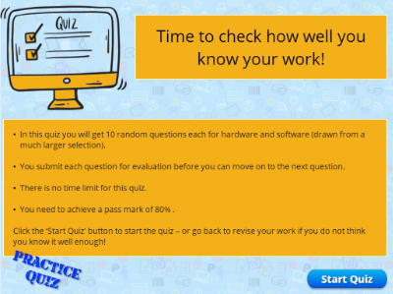
This quiz lets you do random questions with no time limit. It will be slightly different each time you take it.

Practice Quiz - ALL QUESTIONS
This quiz lets you do all the questions in the Hardware and Software quiz.
You do not have to complete the quiz all at once, but can come back and continue where you left off.

FINAL QUIZ!
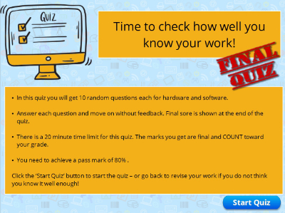
This quiz lets you do random questions - with a time limit.
NB: This quiz can only be taken once and your marks are final.

Data vs Information Quizzes

Practice Quiz
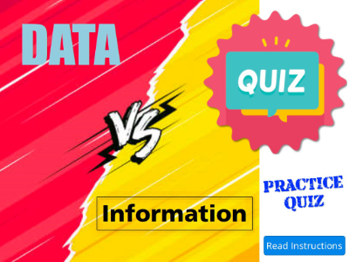
This quiz lets you do random questions with no time limit. It will be slightly different each time you take it.

Practice Quiz - ALL QUESTIONS
This quiz lets you do all the questions in the Data vs Information quiz.
You do not have to complete the quiz all at once, but can come back and continue where you left off.

FINAL QUIZ!
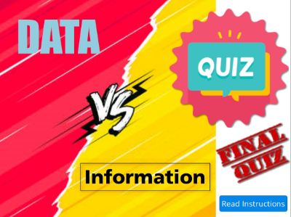
This quiz lets you do random questions - with a time limit.
NB: This quiz can only be taken once and your marks are final.
Games
A Crossword puzzle with a random selection of words from this chapter's terminology
